AdaBoost Algorithm

What Is the AdaBoost Algorithm?

There are many machine learning algorithms to choose from for your problem statements. One of these algorithms for predictive modeling is called AdaBoost.

AdaBoost algorithm, short for Adaptive Boosting, is a Boosting technique used as an Ensemble Method in Machine Learning. It is called Adaptive Boosting as the weights are re-assigned to each instance, with higher weights assigned to incorrectly classified instances.
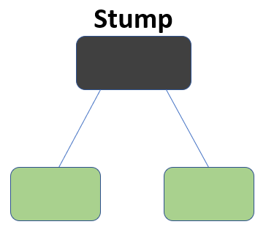

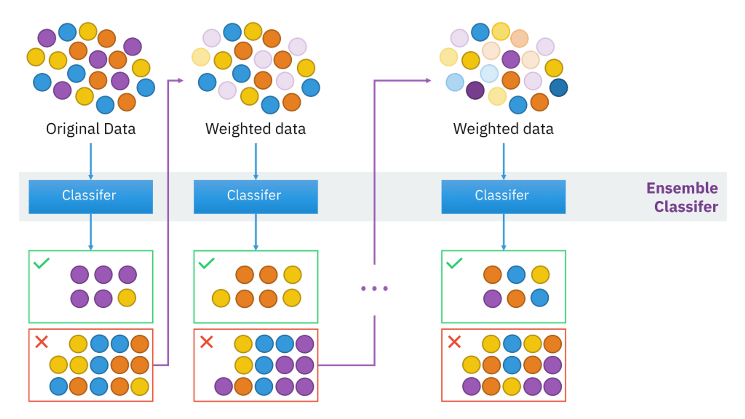
What this algorithm does is that it builds a model and gives equal weights to all the data points. It then assigns higher weights to points that are wrongly classified. Now all the points with higher weights are given more importance in the next model. It will keep training models until and unless a lower error is received.
Let’s take an example to understand this, suppose you built a decision tree algorithm on the Titanic dataset, and from there, you get an accuracy of 80%. After this, you apply a different algorithm and check the accuracy, and it comes out to be 75% for KNN and 70% for Linear Regression.
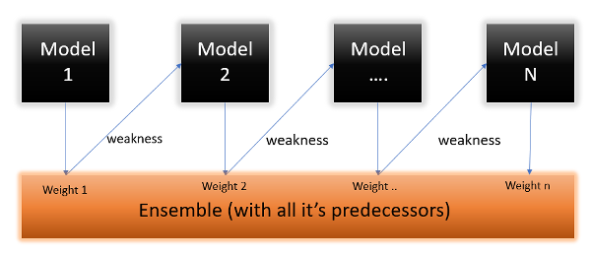
When building different models on the same dataset, we observe variations in accuracy. However, leveraging the power of AdaBoost classifier, we can combine these algorithms to enhance the final predictions. By averaging the results from diverse models, Adaboost allows us to achieve higher accuracy and bolster predictive capabilities effectively.

How AdaBoost Works
To understand how AdaBoost works, smash down its working mechanism right into a step-by-step process:
1. Weight Initialization
At the start, every schooling instance is assigned an identical weight. These weights determine the importance of every example in the getting-to-know method.
2. Model Training
A weak learner is skilled at the dataset, with the aim of minimizing class errors. A weak learner is usually an easy model, which includes a selection stump (a one-stage decision tree) or a small neural network.
3. Weighted Error Calculation
After the vulnerable learner is skilled, its miles are used to make predictions at the education dataset. The weighted mistakes are then calculated by means of summing up the weights of the misclassified times. This step emphasizes the importance of the samples which are tough to classify.
4. Model Weight Calculation
The weight of the susceptible learner is calculated primarily based on their Performance in classifying the training data. Models that perform properly are assigned higher weights, indicating that they're more reliable.
5. Update Instance Weights
The example weights are updated to offer more weight to the misclassified samples from the previous step. This adjustment focuses on the studying method at the times that the present-day model struggles with.
6. Repeat
Steps 2 through five are repeated for a predefined variety of iterations or till a distinctive overall performance threshold is met.
7. Final Model Creation
The very last sturdy model (also referred to as the ensemble) is created by means of combining the weighted outputs of all weak newcomers. Typically, the fashions with better weights have an extra influence on the final choice.
8. Classification
To make predictions on new records, AdaBoost uses the very last ensemble model. Each vulnerable learner contributes its prediction, weighted with the aid of its significance, and the blended result is used to categorize the enter.

Key Concepts in AdaBoost
To gain deeper information about AdaBoost, it's critical to be acquainted with some key principles associated with the algorithm:
1. Weak Learners
Weak novices are the individual fashions that make up the ensemble. These are generally fashions with accuracy barely higher than random hazards. In the context of AdaBoost, weak beginners are trained sequentially, with each new model focusing on the instances that preceding models determined difficult to classify.
2. Strong Classifier
The strong classifier, additionally known as the ensemble, is the final version created by combining the predictions of all weak first-year students. It has the collective know-how of all of the fashions and is capable of making correct predictions.
3. Weighted Voting
In AdaBoost, every susceptible learner contributes to the very last prediction with a weight-based totally on its Performance. This weighted vote-casting machine ensures that the greater correct fashions have a greater say in the final choice.
4. Error Rate
The error rate is the degree of ways a vulnerable learner plays on the schooling statistics. It is used to calculate the load assigned to each vulnerable learner. Models with lower error fees are given higher weights.
5. Iterations
The range of iterations or rounds in AdaBoost is a hyperparameter that determines what number of susceptible newbies are educated. Increasing the range of iterations may additionally result in a more complex ensemble; however, it can also increase the risk of overfitting.

Advantages of AdaBoost
AdaBoost gives numerous blessings that make it a popular choice in gadget mastering:
1. Improved Accuracy
AdaBoost can notably improve the accuracy of susceptible, inexperienced persons, even when the usage of easy fashions. By specializing in misclassified instances, it adapts to the tough areas of the records distribution.
2. Versatility
AdaBoost can be used with a number of base newbies, making it a flexible set of rules that may be carried out for unique forms of problems.
3. Feature Selection
It routinely selects the most informative features, lowering the need for giant function engineering.
4. Resistance to Overfitting
AdaBoost tends to be much less at risk of overfitting compared to a few different ensemble methods, thanks to its recognition of misclassified instances.

Limitations and Challenges
While AdaBoost is an effective algorithm, it is important to be aware of its barriers and challenges:
1. Sensitivity to Noisy Data
AdaBoost may be sensitive to noisy facts and outliers because it offers greater weight to misclassified times. Outliers can dominate the studying system and result in suboptimal consequences.
2. Computationally Intensive
Training AdaBoost may be computationally intensive, especially while using a massive wide variety of susceptible learners. This could make it much less appropriate for real-time applications.
3. Overfitting
Although AdaBoost is much less prone to overfitting than a few different algorithms, it may nonetheless overfit if the number of iterations is too excessive.
4. Model Selection
Selecting the proper vulnerable learner and tuning hyperparameters may be difficult, as the Performance of AdaBoost is noticeably dependent on these alternatives.

Practical Applications
AdaBoost has found applications in a huge range of domains, along with but not constrained to:
1. Face Detection
AdaBoost has been used in computer imagination and prescient for obligations like face detection, in which it allows the perception of faces in pics or motion pictures.
2. Speech Recognition
In speech popularity, AdaBoost can be used to improve the accuracy of phoneme or word popularity structures.
3. Anomaly Detection
AdaBoost can be applied to anomaly detection problems in numerous fields, such as finance, healthcare, and cybersecurity.
4. Natural Language Processing
In NLP, AdaBoost can decorate the overall Performance of sentiment analysis and textual content category fashions.
5. Biology and Bioinformatics
AdaBoost has been used for protein type, gene prediction, and different bioinformatics duties.

Disadvantages of Boosting Algorithms
Boosting algorithms also have some disadvantages these are:
- Boosting Algorithms are vulnerable to the outliers
- It is difficult to use boosting algorithms for Real-Time applications.
- It is computationally expensive for large datasets

Difference Between Boosting Algorithms
Algorithms | Gradient Boosting | AdaBoost | XGBoost | CatBoost | LightGBM
Year | – | 1995 | 2014 | 2017 | 2017
Handling Categorical Variables | May require preprocessing like one-hot encoding | No | NO | Automatically handles categorical variables | No
Speed/Scalability | Moderate | Fast | Fast | Moderate | Fast
Memory Usage | Moderate | Low | Moderate | High | Low
Regularization | No | No | Yes | Yes | Yes
Parallel Processing | No | No | Yes | Yes | Yes
GPU Support | No | No | Yes | Yes | Yes
Feature Importance | Available | Available | Available | Available | Available

